ITA 0435 – STATISTICS WITH R PROGRAMMING FOR VISUALIZATION
ANALYTICAL ASSIGNMENT -2
NAME : R.SABARISH
REG NO : 192324092
1. STUDENT RESULT PROCESSING SYSTEM

# STUDENT RESULT PROCESSING SYSTEM

# Input marks matrix (rows = students, columns = subjects)
marks <- matrix(
c(80,75,90,
40,50,45,
60,65,70,
30,35,25),
nrow = 4,
byrow = TRUE
)

colnames(marks) <- c("Subject1","Subject2","Subject3")
rownames(marks) <- paste("Student",1:4)

# Initialize vectors
total_marks <- c()
grades <- c()

# For loop to calculate total marks
for(i in 1:nrow(marks)){
total_marks[i] <- sum(marks[i, ])
}

# Calculate percentage using arithmetic operators
percentage <- (total_marks / 300) * 100

# Assign grades using if-else and boolean operators
for(i in 1:length(percentage)){

if(percentage[i] >= 80){
grades[i] <- "A"

} else if(percentage[i] >= 60 & percentage[i] < 80){
grades[i] <- "B"

} else if(percentage[i] >= 40 & percentage[i] < 60){
grades[i] <- "C"

} else {
grades[i] <- "Fail"
}
}

# Identify failed students using logical condition
failed_students <- rownames(marks)[grades == "Fail"]

# Function with default argument to calculate percentage
calculate_percentage <- function(total, max_marks = 300){
percent <- (total / max_marks) * 100
return(percent)
}

# Function returning complex object (list)
student_result <- function(total, max_marks = 300){

percent <- calculate_percentage(total, max_marks)

if(percent >= 80){
grade <- "A"
} else if(percent >= 60){
grade <- "B"
} else if(percent >= 40){
grade <- "C"
} else {
grade <- "Fail"
}

return(list(
Total = total,
Percentage = percent,
Grade = grade
))
}

# Generate result summary for all students
results <- list()

for(i in 1:length(total_marks)){
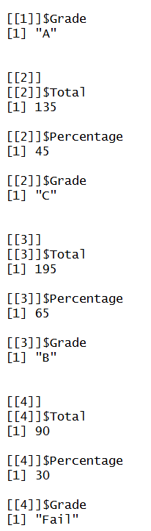
results[[i]] <- student_result(total_marks[i])
}

# Display outputs
marks
total_marks
percentage
grades
failed_students
results

2. BANKING INTEREST CALCULATION SYSTEM
# BANKING INTEREST CALCULATION SYSTEM

# Initial values
principal <- 10000
rate <- 0.08
target_amount <- 20000
time <- 0
balance <- principal

# While loop to calculate compound interest until target is reached
while(balance < target_amount){

time <- time + 1

# Compound interest formula: A = P(1 + r)
balance <- balance * (1 + rate)

# Skip calculation if balance becomes NA
if(is.na(balance)){
next
}

# Stop loop if balance exceeds double the target (safety condition)
if(balance > target_amount * 2){
break
}
}

balance
time

# Function with default interest rate and time period
calculate_compound <- function(principal, rate = 0.05, years = 5){

amount <- principal * (1 + rate)^years

# Implicit return (last evaluated expression is returned)
amount
}

calculate_compound(10000)

# Function returning multiple outputs (complex object)
calculate_details <- function(principal, rate = 0.05, years = 5){

final_amount <- principal * (1 + rate)^years

total_interest <- final_amount - principal

return(list(
Final_Amount = final_amount,
Total_Interest = total_interest,
Years = years
))
}

calculate_details(10000, 0.08, 3)

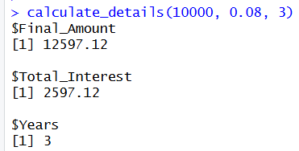

3. INVENTORY MANAGEMENT SYSTEM
# INVENTORY MANAGEMENT SYSTEM

# Create a list of products (non-vector structure)
inventory <- list(
list(name="Shirt", stock=20),
list(name="Jeans", stock=5),
list(name="Shoes", stock=12),
list(name="Jacket", stock=3),
list(name="Cap", stock=15)
)

# Define threshold for low stock
threshold <- 10

# For loop to iterate over list (non-vector set)
for(i in 1:length(inventory)){

product_name <- inventory[[i]]$name
product_stock <- inventory[[i]]$stock

# Identify low stock using if-else
if(product_stock < threshold){
cat(product_name, "is LOW in stock\n")
} else {
cat(product_name, "has sufficient stock\n")
}
}

cat("\n")

# Apply boolean operators for multiple conditions
for(i in 1:length(inventory)){

stock <- inventory[[i]]$stock

# Check if stock is low AND positive
if(stock < threshold & stock > 0){
cat(inventory[[i]]$name, "needs restocking\n")
}

# Check if stock is zero OR negative
if(stock <= 0 | is.na(stock)){
cat(inventory[[i]]$name, "is OUT OF STOCK\n")
}
}

cat("\n")

# Function to update stock and return complex object
update_stock <- function(product_list, restock_amount = 10){

updated_inventory <- product_list
low_stock_items <- c()

for(i in 1:length(updated_inventory)){

if(updated_inventory[[i]]$stock < threshold){

low_stock_items <- c(low_stock_items, updated_inventory[[i]]$name)

updated_inventory[[i]]$stock <-
updated_inventory[[i]]$stock + restock_amount
}
}

# Returning complex object (list)
return(list(
Updated_Inventory = updated_inventory,
Restocked_Products = low_stock_items
))
}

# Call function
result <- update_stock(inventory)

# Display results
result$Updated_Inventory
result$Restocked_Products

# Demonstrating that functions are objects
f <- update_stock
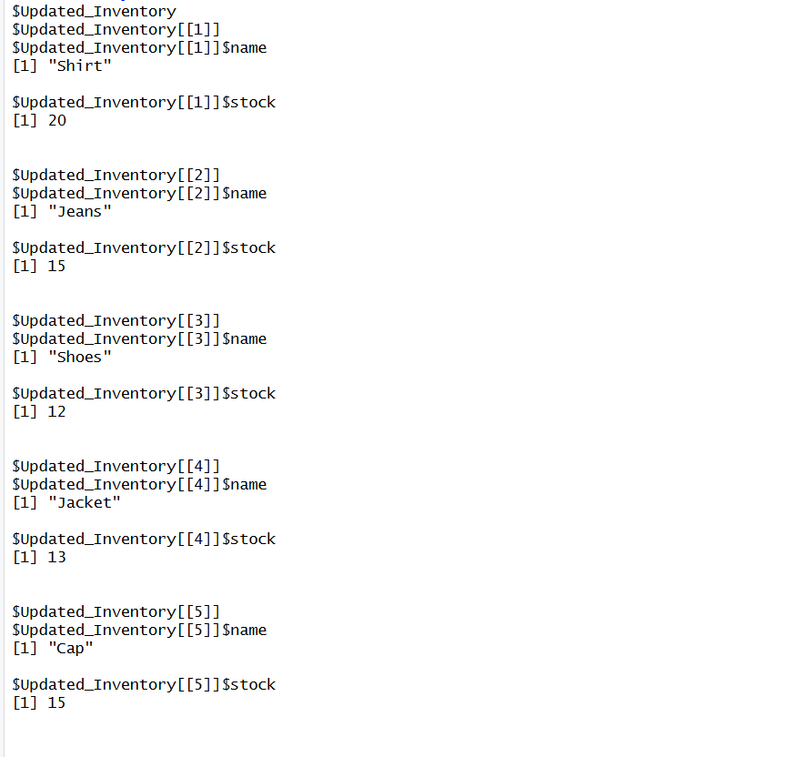
f(inventory)

4. FACTORIAL AND FIBONACCI CALCULATOR
# FACTORIAL AND FIBONACCI CALCULATOR

# 1️⃣ Factorial using for loop (iterative approach)
factorial_loop <- function(n){

if(n < 0){
return("Factorial not defined for negative numbers")
}

result <- 1

for(i in 1:n){
result <- result * i
}

return(result)
}

# Example
factorial_loop(5)

# 2️⃣ Factorial using recursion
factorial_recursive <- function(n){

# Base condition
if(n == 0 || n == 1){
return(1)
}

# Recursive call
return(n * factorial_recursive(n - 1))
}

# Example
factorial_recursive(5)

# 3️⃣ Fibonacci using recursion
fibonacci_recursive <- function(n){

# Base conditions
if(n == 0){
return(0)
}
if(n == 1){
return(1)
}

# Recursive calls
return(fibonacci_recursive(n - 1) + fibonacci_recursive(n - 2))
}

# Example
fibonacci_recursive(6)

# 4️⃣ Repeated calculation using repeat loop
repeat{

num <- 5

cat("Factorial (Loop):", factorial_loop(num), "\n")
cat("Factorial (Recursive):", factorial_recursive(num), "\n")
cat("Fibonacci:", fibonacci_recursive(num), "\n")

break
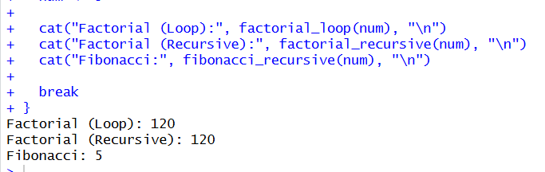
}

5. ONLINE QUIZ EVALUATION SYSTEM
# ONLINE QUIZ EVALUATION SYSTEM

# Correct answers
correct_answers <- c("A","C","B","D","A")

# Students' answers (each row = one student)
student_answers <- list(
c("A","C","B","D","A"),
c("A","C","X","D","A"),
c("A","C","B","CHEAT","A")
)

# Function to evaluate quiz
evaluate_quiz <- function(answers_list, correct,
marks_correct = 5,
marks_wrong = -1){

results <- list()

for(i in 1:length(answers_list)){

answers <- answers_list[[i]]
total_score <- 0
j <- 1

while(j <= length(correct)){

# Stop evaluation if cheating detected
if(answers[j] == "CHEAT"){
cat("Cheating detected for Student", i, "\n")
break
}

# Skip invalid entries
if(!(answers[j] %in% c("A","B","C","D"))){
j <- j + 1
next
}

# Compare answers using if-else
if(answers[j] == correct[j]){
total_score <- total_score + marks_correct
} else {
total_score <- total_score + marks_wrong
}

j <- j + 1
}

percentage <- (total_score / (length(correct) * marks_correct)) * 100

if(percentage >= 50){
status <- "Pass"
} else {
status <- "Fail"
}

# Store result as complex object
results[[i]] <- list(
Total_Score = total_score,
Percentage = percentage,
Result = status
)
}

return(results)
}

# Call function
quiz_results <- evaluate_quiz(student_answers, correct_answers)
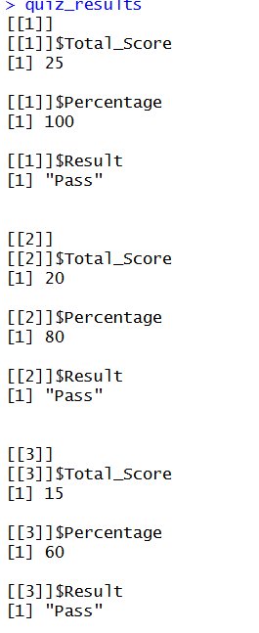
quiz_results

